MOVIE RECOMMENDATION

Cosine similarity is the cosine of the angle between two n-dimensional vectors in an n-dimensional space. It is **the dot product of the two vectors divided by the product of the two vectors' lengths (or magnitudes)**.

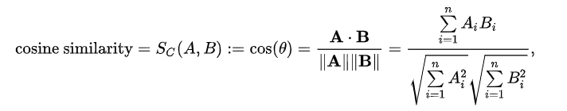

**Example**

from sklearn.metrics.pairwise import cosine_similarity

vec1 = [1,1,0,1,1]

vec2 = [0,1,0,1,1]

print(cosine_similarity([vec1, vec2]))

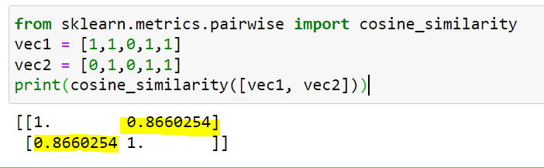

vec1 * vec2 = 1*0+1*1+0*0+1*1+1*1 = 0+1+0+1+1= 3

SQRT(1*1+1*1+0*0+1*1+1*1) = SQRT(1+1+0+1+1) = SQRT(4) = 2

SQRT(0*0+1*1+0*0+1*1+1*1) = SQRT(0+1+0+1+1) = SQRT(3) = 1.73

Cosine Similarity = 3/ (2*1.73) = 3/ 3.46 = 0.8670

**Import Libraries**

import numpy as np

import pandas as pd

import difflib

from sklearn.feature_extraction.text import TfidfVectorizer

# TfidfVectorizer - This is used to convert text data into numerical values

from sklearn.metrics.pairwise import cosine_similarity

import os

**Check the current working directory**

display (os.getcwd())

**Change the current working directory and read data**

os.chdir('C:\\Noble\\Training\\Acmegrade\\Data Science\\Projects\\PRJ Movie Recommendation\\')

movies_data =pd.read_csv('movies.csv')

movies_data.head()

**Display the shape**

display (movies_data.shape)

**Selecting the relevant features for recommendation**

selected_features = ['genres','keywords','tagline','cast','director']

print(selected_features)

**Display the info**

display (movies_data.info())

**Check for Null Values**

display (movies_data.isna().sum())

**Display the selected columns**

display (movies_data[selected_features].head())

**Check Null Values in selected columns**

display (movies_data[selected_features].isna().sum())

**Replacing the null values with null string**

for feature in selected_features:

movies_data[feature] = movies_data[feature].fillna('')

display (movies_data.head())

**Combining all the 5 selected features**

combined_features = movies_data['genres']+' '+movies_data['keywords']+' '+movies_data['tagline']+' '+movies_data['cast']+' '+movies_data['director']

display (combined_features)

**Converting the text data to feature vectors**

This is to find cosine similarity

# Vector shape is (4803, 17318). This is based on the number of distinct words. All the words will be converted to their equivalent numbers.

vectorizer = TfidfVectorizer()

feature_vectors = vectorizer.fit_transform(combined_features)

display (feature_vectors.shape)

print (feature_vectors)

**Getting the similarity scores using cosine similarity**

similarity = cosine_similarity(feature_vectors)

print (similarity )

**Print Shape Cosine Similarity**

display(similarity.shape)

**Enter the movie name to get Similarity**

movie_name = input(' Enter your favourite movie name : ')

**Creating a list with all the movie names given in the dataset**

list_of_all_titles = movies_data['title'].tolist()

print(list_of_all_titles)

**Length of the List**

len(list_of_all_titles)

**Finding the close match for the movie name given by the user**

find_close_match = difflib.get_close_matches(movie_name, list_of_all_titles)

print(find_close_match)

**Display the close match**

close_match = find_close_match[0]

print(close_match)

**Finding the index of the movie with the title**

index_of_the_movie = movies_data[movies_data.title == close_match]['index'].values[0]

print(index_of_the_movie)

**Get the similarity row for the selected index**

These are the similarity values for the movie entered by the user

similarity_score = list(enumerate(similarity[index_of_the_movie]))

print(similarity_score)

**Length of Similarity Score**

len(similarity_score)

**Sorting the movies based on their similarity score**

Display the index and similarity rating as a tuple

This list is sorted based on the similarity score

**Print the name of similar movies based on the index – Top 30**

print('Movies suggested for you : \n')

i = 1

for movie in sorted_similar_movies:

index = movie[0]

title_from_index = movies_data[movies_data.index==index]['title'].values[0]

if (i<30):

print(i, '.',title_from_index)

i+=1

**Consolidated code**

movie_name = input(' Enter your favourite movie name : ')

list_of_all_titles = movies_data['title'].tolist()

find_close_match = difflib.get_close_matches(movie_name, list_of_all_titles)

close_match = find_close_match[0]

index_of_the_movie = movies_data[movies_data.title == close_match]['index'].values[0]

similarity_score = list(enumerate(similarity[index_of_the_movie]))

sorted_similar_movies = sorted(similarity_score, key = lambda x:x[1], reverse = True)

print('Movies suggested for you : \n')

i = 1

for movie in sorted_similar_movies:

index = movie[0]

title_from_index = movies_data[movies_data.index==index]['title'].values[0]

if (i<30):

print(i, '.',title_from_index)

i+=1